Bottom-Up Evaluation of S-Attributed Syntax-Directed Definition

AIM
To write a C program to perform bottom-up evaluation of an S-attributed syntax-directed definition for the given grammar and display the final evaluated value.
Grammar:
- E → E + T
- E → T
- T → num

ALGORITHM
- Start the program.
- Read the arithmetic expression.
- Initialize an empty stack.
- Scan the expression from left to right.
- If a digit is found, convert it into a number and push it onto the stack.
- Ignore the plus operator.
- Perform bottom-up evaluation by adding the stack elements.
- Display the final value of E.
- Stop the program.

PSEUDOCODE
START
Read arithmetic expression
Initialize stack
Set top = -1

FOR each character in expression
IF character is a digit
Convert digits into number
Push number into stack
ELSE IF character is '+'
Continue
ELSE
Display Invalid Expression
STOP
END IF
END FOR

WHILE stack contains more than one value
Pop top value
Add it to previous value
Store result in stack
END WHILE

Display final value of E
STOP

PROGRAM
#include <stdio.h>
#include <ctype.h>
#include <stdlib.h>

int main()
{
char exp[100];
int stack[100];
int top = -1;
int i = 0, num;

printf("Enter expression: ");
scanf("%s", exp);

while (exp[i] != '\0')
{
if (isdigit(exp[i]))
{
num = 0;

while (isdigit(exp[i]))
{
num = num * 10 + (exp[i] - '0');
i++;
}

stack[++top] = num;
}
else if (exp[i] == '+')
{
i++;
}
else
{
printf("Invalid expression\n");
return 1;
}
}

while (top > 0)
{
int t = stack[top--];
int e = stack[top];

stack[top] = e + t;
}

printf("Value of E = %d\n", stack[top]);

return 0;
}

INPUT
3+8

OUTPUT
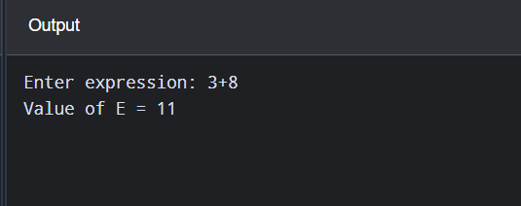

RESULT
Thus, the C program to perform bottom-up evaluation of an S-attributed syntax-directed definition was successfully executed.

